Lavaca County 4-H News
October 6, 2023
always keep an eye on https://lavaca.agrilife.org/ and our Facebook page https://www.facebook.com/LavacaCounty4H.

ATTENTION: Only those members and leaders who have completed their online registration and are now in the approved membership list are receiving this newsletter. Please encourage your friends to re-enroll.

2023-2024 Enrollment Price Increases to $30 on November 1st.
Encourage your friends to join before the price goes up!

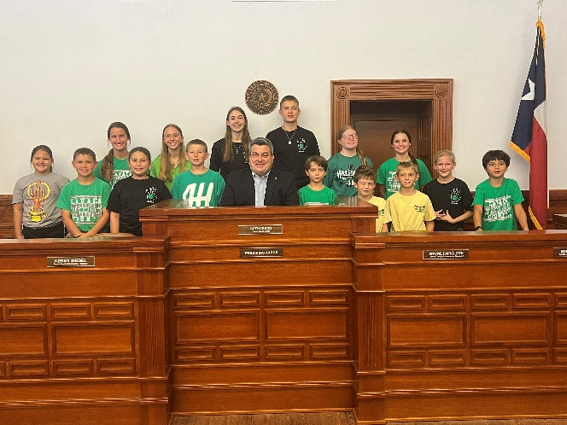
National 4-H Week!

Thank you to those who were able to take a picture with Judge Mudd in Honor of National 4-H Week!
Back Row L to R: Lindsey Orsak, Macey Pustka, Keely Knesek, Amanda Janak, Ryan Janak, Madison Coburn, Ashlyn Pustka
Front Row L to R: Tanner Pustka, Preslie Haas, Karter Haas, Axel Foerster, Slade Jacobs, Sutton Jacobs, Ellasyn Klekar, and Cason Foerster

4-H BBQ
This Sunday, October 8, 2023
Everyone’s Help is Needed!
Friday afternoon - peel onions
Saturday morning – 7:30 a.m. peel potatoes
Sunday 10:00 a.m. – 11:30 a.m
11:30 a.m. – 1:00 p.m.
1:00 p.m. until everything is cleaned up
Cookies - Each club is required to supply 120 bags of cookies.
Each zip lock bag should contain two homemade cookies that are at least 3’’ in diameter.
One Day 4-H- October 7, 2023
One Day 4-H is a day set aside each year for 4-H members across the state to make an impact in their communities all at the same time. For more information on One Day 4-H go to
https://texas4-h.tamu.edu/events/oneday/
If you download the One Day packet, you will find a great listing of community service ideas by project area that can be done at anytime during the year. Check it out!

4-H Fun Fair
Sunday, October 15, 2023
Youth Center
Hallettsville City Park

- 12:30 –Help will be needed to set up tables
- 1:00 – Club Chili Cook-Off Check In and Begin Cooking- Lavaca County Chili Cookoff RULES 2023 – 8 teams entered!
- 2:00 – Doors Open to Public
- Bake Show (items must be received by 2:30) : Fun Fair Bake Show Rules 2023
- Talent Showcase: Come show off your talent —sing, dance, act, recite poetry, tell a joke, twirl, play an instrument —the stage is yours! Open to Kindergarten to 12th grade. Non-members pay a $2 entry fee. Approved members can enter for free. Sign up at the registration table by 2:30. Performances will begin at 2:45 p.m.
- Informational Booths –tell others about your projects –make a poster, bring items to show –booths need to be set up before 2:00 and stay up until 4:30.
- Petting Zoo---we need animals and workers! Please communicate with Natalie if you can help! Use the sign up genius link or email natalie.knesek@ag.tamu.edu
- Food Drive for Golden Crescent Children’s Project benefitting the homeless youth of our area. Please bring one of the following items as a donation: ravioli (with pull tab), poptarts, fruit cups, individual gold fish packs, individual chips bags, ramen noodles in a cup, granola bars, cheese crackers, mac n cheese in a cup, individual cereal packs, small waters, small sport drinks
- 4:15: results will be announced for the chili cookoff, talent showcase, and bake show
- 5:00 --help will be needed to clean up!

Fun Fair is a great time for us to come together as a county and introduce others to 4-H. We need lots of help to make the day successful. Use this sign-up link to volunteer for some of the jobs we will have (adults and members are both needed)!
https://www.signupgenius.com/go/9040944AAA72FA2FD0-2023

Major Show and Hallettsville Lamb and Goat Validation
October 10th 4:00 p.m -6:00 p.m.

**NEW** All state validated heifers will be tagged similar to steers. This will bring the heifer validation program in line with breeding sheep, breeding goats, and breeding gilts. Please order tags accordingly. This is a change from the heifer UINs where you were charged based on animals validated, not ordered. Those planning to show a heifer at any major livestock show must order and pay for a tag by the deadline. Please order accurately. No refunds will be given for unused tags. This is the last opportunity to validate a heifer for the 2024 major shows. Heifers validated in June do not need to be revalidated. Order forms for all major show animals listed above are at the end of this newsletter and available in the oﬃce.

Hallettsville Junior Livestock Show Broiler Orders
Hallettsville Junior Livestock Show broiler orders are due in the Extension Office TODAY!
Order form is at the back of this newsletter.

Moulton Show Lamb and Pig Validation
Saturday, October 21
8:00 a.m. – 9:00 a.m.
at the Ag Shop
Shiner rabbit Validation
October 18
6:00 p.m. – 7:00 p.m.
Ward Pavilion, Green Dickson Park
Shiner Junior Livestock Show is November 18

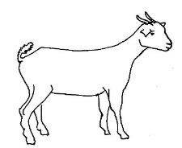
This Photo by Unknown Author is licensed under CC BY-SA-NC
Lavaca County Lamb, Goat and Beef Project Clinic
October 28

Major Show and Hallettsville Swine Validation and Last Chance
to validate Hallettsville Halter Heifers
Tuesday, November 14 4:00 p.m. -6:00 p.m.
Thursday, November 16 5:00 p.m. – 6:00 p.m.
Lavaca County Expo Center

Quality Counts
If you participate in any of the major shows, you must have a a current quality counts certificate on file to enter. You obtain the certificate one time in each age division based on grade: junior (3-5), intermediate (6-8) and senior (9-12). Please note, new this year –each member must have their own email address in the quality counts system. If they do not have an email account, you will need to go create a new email for them in a free service like gmail or yahoo ahead of logging in to quality counts.
Access quality counts here:
https://agrilifelearn.tamu.edu/s/product/quality-counts-archive/01t4x000002ciQSAAY

Today is the last day to register at regular price for District Crossroads
Career Development and Youth Leadership Program
Information for the 2023 - 2024 District 11 Crossroads is now available at the event website: https://d114-h.tamu.edu/events-and-contests/crossroads/. The event will be held November 9-11, 2023, in Brenham, TX. The event is open to D11 4-H youth in grades 8 through 12 as of November 9, 2023.
Registration will open on 4-H Online from September 5 – October 6, 2023. Late registration will be open from October 7 – 20, 2023. Please share this information with your 4-H families.

Meeting Date Changes for October: Half Moon – October 15 and Lucky H -October 24

County Food Show and Food Challenge
Sunday, November 5, 2023
Tentative Times
Food Show 1:30-3:00
Food Challenge 3:00 – 6:00
Entry Forms will be due October 30th
Location TBA

County Council and Adult Volunteer Meeting
Monday, November 13
7:00 p.m.
Extension Office
We need involvement from all of the clubs at county council!
Each club should have delegates and adult volunteers attending.
Club delegates are expected to give a short report on what their club is doing and also take county business back to their club to report at their meetings. This is an excellent way to become more involved and develop leadership and presentation skills.

The 2024 Texas 4-H Roundup Handbook is now posted at https://texas4-h.tamu.edu/events/roundup/

Reimbursement for Select Activities
The reimbursement policy was approved by the council and remains the same for 2023. Members may request reimbursement for a number of activities including participation at the Texas 4-H Center and entry fees for 4-H
contests. Refer to the policy for details. Go to http://counties.agrilife.org/lavaca/files/2022/01/Lavaca-County-4-H-Reimbursement- Policy-and- Forms.pdf to access the policy and forms.
There are LOTS of opportunities that do not get included in this newsletter. Make sure you are also reading the weekly email from Texas 4-H and following Texas 4-H on social media so you do not miss out. There is just more than we can possibly keep up with and share. If you participate in something, please send us a picture or two and let us know what you learned and what you did so we can spotlight you in this newsletter or on our Facebook page!
The Extension Office will be closed on Monday, October 9, 2023.
Texas A&M AgriLife Extension provides equal opportunities in its programs and employment to all persons, regardless of race, color, sex, religion, national origin, disability, age, genetic information, veteran status, sexual orientation, or gender identity. The Texas A&M University System, U.S. Department of Agriculture, and the County Commissioners Courts of Texas Cooperating Individuals with disabilities who require an auxiliary aid, service or accommodation in order to participate in any Extension activity, are encouraged to contact the County Extension Office (361)798-2221 to determine how reasonable accommodations can be made.

