Lavaca County 4-H 2021 T-Shirt Design Contest

We need to order new shirts to represent Lavaca County 4-H! The winner of this design contest will have their design placed on t-shirts that will be made available to purchase in the Extension Office. Price and style of shirts will be determined after the design is selected.
This contest is open to all members of Lavaca County 4-H. First, second, and third place winners will be chosen anonymously by a panel of judges. The winner will receive a $10 gift card and a t-shirt. Second and third place winners will receive $5 gift cards and discounts on a shirt.
Your design should represent Lavaca County 4-H. Be careful not to use copyrighted images. The 4-H Clover is trademarked and can be accessed on the Texas 4-H website. Please include the clover, but be sure to use it appropriately, following the trademark rules found at the very bottom of this page: https://texas4-h.tamu.edu/management/
Your entry must have the following four pages in order:
- The Contest Cover Sheet – This sheet filled in and signed by you and a parent/guardian.
- The T-Shirt Template Form – this form with your renderings in the correct placement
- Scaled Drawing of the Front Design in black ink to be given to the printer if you win
- Scaled Drawing of the Back Design in black ink to be given to the printer if you win
*****Only place your name on your cover page. Your entry will be numbered, and your cover page separated so that it may be judged anonymously.
All Entries Must be Submitted By Wednesday, March 3, 2021 to the County Extension Office. Please place your entries in a folder or envelope to protect them.

Name_______________________________Club_____________________________________

By signing this form you are entering the contest and agreeing to the following statement:

The work presented here is mine and mine only. It is my original design. I have taken care to not use copyrighted materials. I have used the 4-H Clover is such a way that it abides by the trademark standards.

______________________________________ __________________________
Your Name and Date Your Parent/Guardian Name/Date

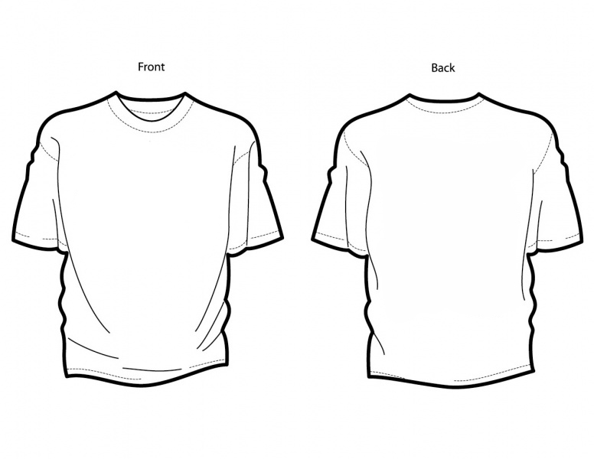
Lavaca County 4-H 2021 T-Shirt Contest Template

This page goes directly behind the cover page and should have one page each for larger drawings of the front and back designs. Use this page to depict where your designs will be placed on the shirt. Place your full-size designs on separate sheets of paper behind the cover page and this template.

