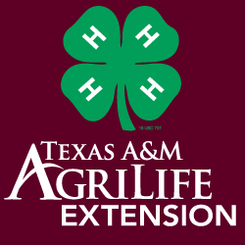
2020 Lavaca County
4-H Food Show and Food Challenge
Entry Form

This form is due by Wednesday October 7, 2020
Contest: October 17, 2020 2:00 p.m.
Food Challenge will immediately follow Food Challenge

Name________________Grade__________Club___________
Food Challenge:
- I plan to participate in food challenge.
Team Name:
Other Members on Team:

- I do not plan to participate in food challenge.
Food Show: (attach the required recipe form to this sheet)
- I plan to participate in food show and have attached my required recipe form.
- I do not plan to participate in food show.
I understand that I must be enrolled as an active member in Lavaca County 4-H and be academically eligible to participate in the county food show. I have the permission of my parent or guardian to participate and am responsible for arriving prepared.

Member Signature Parent Signature

